Hockley Parish Council Update April 2020
We owe a debt of gratitude to all the super heroes in the NHS and emergency services, and to an army of local unsung heroes; neighbours, friends, pharmacies and businesses who have ensured Hockley is kept supplied with food and other essential services. In common with many of our residents, the majority of our councillors are experiencing life in isolation due to health or age restrictions. However, the Parish Council continues to operate, using other methods of communication, but have drawn the line at smoke signals! Our staff are working from home and if you have any concerns which need immediate attention please email or phone the Parish Office as a remote link is being maintained. Well done to Dave, our Parish Ranger who has continued to be busy around the village with grass cutting and maintenance work.
Elections: Elections were due to be held in May 2020 which the Government has put back until 6th May 2021. As your Hockley Parish Council representatives were up for election in May, the members will serve residents for a further year.
Council Audits Work continues on the year end audit. Local Council Audit time frames were published by the Government on 7th April 2020 which will come into force on 30th April 2020. These extend the statutory audit deadlines for 2019/2020 from 30th September to 30th November. The public inspection period will commence on or before the first working day of September 2020.
Events: The Government are scaling down national celebrations including those for VE Day in May. Much of our own plans for community events have also had to be postponed. To help lift our spirits the Parish Council will fill the planters and baskets with red, white and blue displays this year and bunting will soon be seen around the village ready for VE Day on 8th May. Once the crisis abates, we will turn our attention to VJ Day on 15th August to give the Second War Generation the fitting tribute they deserve.
Relief Efforts: As you will know Local Councils are limited in their powers and how they can assist with relief efforts. However, District and Parish Councillors along with many other volunteers are involved in community shielding our vulnerable residents where they can and you will find the latest information and contact details on our website to help you stay safe.
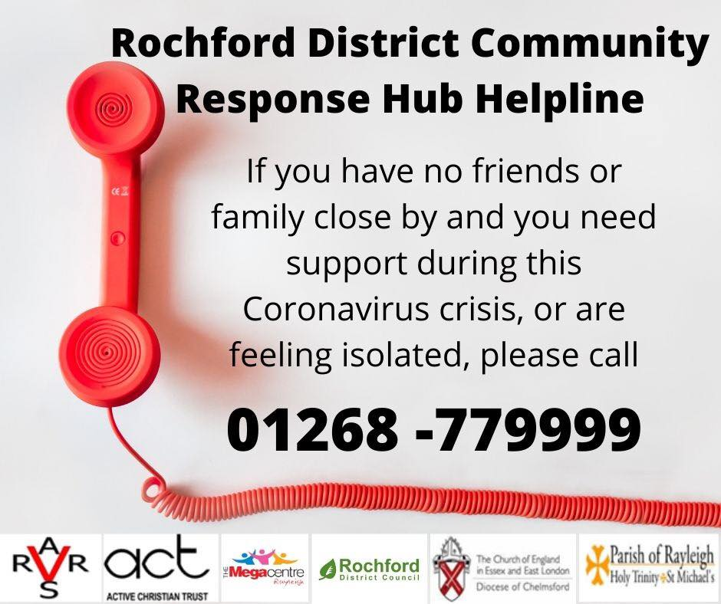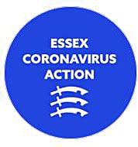
You can also stay in touch with all the latest updates on the Essex Coronavirus Action Facebook page.

