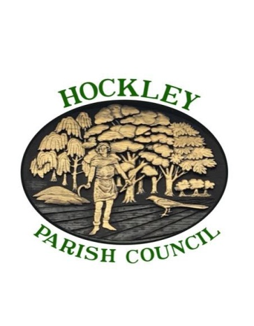
HOCKLEY PARISH COUNCIL
__________________________________________________________________

MINUTES OF THE PLANNING & LOCAL DEVELOPMENT COMMITTEE MEETING HELD ON MONDAY 7th JANUARY 2019
AT 7.00PM IN THE PARISH HALL.

ITEM NO. | SUBJECT
PLN18/165 | It was noted that the Agenda Numbering was incorrect and would be adjusted on the Minutes.  Those present and to receive apologies for absence.  Present: Cllrs N Boxall, M Carter, S Chelmsford. T Gleadall (Chairman),  Mrs S James & Mrs B Thorogood.  Also present: Cllr Mrs S Martin who recorded the minutes  Apologies Received from Cllr Mrs T Carter.  Resolved: To accept apologies from Cllr Mrs T Carter. Proposed Cllr S Chelmsford. Seconded Cllr N Boxall.
PLN18/166 | To Confirm the Minutes of the meeting held 17th December 2018  It was noted that the parish council had responded to RHALC on their survey of planning comments posted on the District Website. Out of 21 submitted by Hockley Parish Council 19 had been recorded to date.  Resolved: To approve the minutes of the meeting held on 17th December 2018 as a correct record. Proposed: Cllr T Gleadall, Seconded: Cllr M Carter.  The minutes were signed by the Committee Chairman
PLN18/167 | Declarations of interest.  None Received.
PLN18/168 | Public participation.  None present.
PLN18/169 | To note progress on the renovation of the Bull Inn  No further information on progress
PLN18/170 | To note the Public Notice issued by ECC on proposed temporary closure of Church Road Hockley.  Temporary Road Closure Notice was noted.
PLN18/171 | To consider Planning Applications Received:  18/00889/FUL  Applicants's Name:  Mr Richard Carlow  Applicants' Address:  28 Chestnut Close, Hockley, SS5 5EQ  Proposal:  Single storey pitched roofed front extension and porch  Unable to comment as this Planning Application came under Ashingdon  Parish Council.
PLN18/172 | Date of next meeting: Monday 21ST January 2019
PLN18/173 | Items for next agenda  The Bull Inn  Meeting closed at 7.15pm

